**EmployeeInfo.cs**

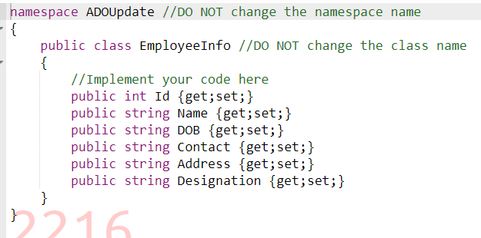

**EmployeeUtility.cs**

**Program.cs**

